Regents Chemistry

Notes:
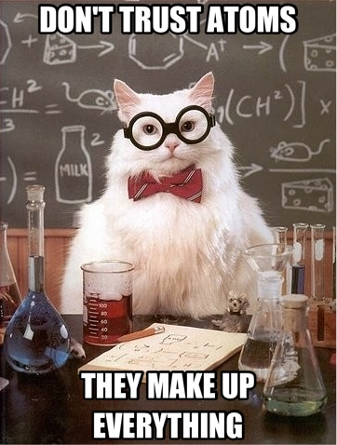
Unit 4: Atomic Structure
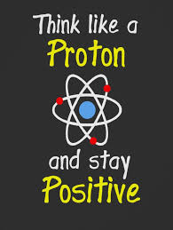

Key Ideas

- The modern model of the atom has evolved over a long period of time through the work of many scientists.(3.1a)
- Each atom has a nucleus, with an overall positive charge, surrounded by one or more negatively charged electrons. (3.1b)
- Subatomic particles contained in the nucleus include protons and neutrons. (3.1c)
- The proton is positively charged, and the neutron has no charge. The electron is negatively charged.(3.1d)
- Protons and electrons have equal but opposite charges. The number of protons equals the number of electrons in an atom. (3.1e)
- The mass of each proton and each neutron is approximately equal to one atomic mass unit. An electron is much less massive than a proton or a neutron. (3.1f)
- The number of protons in an atom (atomic number) identifies the element. The sum of the protons and neutrons in an atom (mass number) identifies an isotope. Common notations that represent isotopes include: 14C, 14C, carbon-14, C-14. (3.1g)
- In the wave-mechanical model (electron cloud model), the electrons are in orbitals, which are defined as the regions of the most probable electron location (ground state). (3.1h)
- Each electron in an atom has its own distinct amount of energy. (3.1i)
- When an electron in an atom gains a specific amount of energy, the electron is at a higher energy state (excited state). (3.1j)
- When an electron returns from a higher energy state to a lower energy state, a specific amount of energy is emitted. This emitted energy can be used to identify an element. (3.1k)
- The outermost electrons in an atom are called the valence electrons. In general, the number of valence electrons affects the chemical properties of an element. (3.1l)
- Elements are substances that are composed of atoms that have the same atomic number. (3.1u)
- Atoms of an element that contain the same number of protons but a different number of neutrons are called isotopes of that element. (3.1m)
- The average atomic mass of an element is the weighted average of the masses of its naturally occurring isotopes. (3.1n)
- When an atom gains one or more electrons, it becomes a negative ion. When an atom loses one or more electrons, it becomes a positive ion. (5.2c)
- Electron-dot diagrams (Lewis structures) can represent the valence electron arrangement in elements and ions. (5.2d)
SKILLS
- Use models to describe the structure of an atom (3.1i)
- Relate experimental evidence to models of the atom (3.1 ii)
- Determine the number of protons or electrons in an atom or ion when given one of these values (3.1iii)
- Calculate the mass of an atom, the number of neutrons or the number of protons, given the other two values. (3.1 iv)
- Distinguish between ground state and excited state electron configurations. (3.1 v)
- Identify an element by comparing its bright-line spectrum to given spectra (3.1 vi)
- Distinguish between valence and non-valence electrons, given an electron configuration (3.1 vii)
- Interpret and write isotopic notation (3.1x)
- Given an atomic mass, determine the most abundant isotope (3.1 xi)
- Calculate the atomic mass of an element, given the masses and ratios of naturally occurring isotopes. (3.1 xii
Vocabulary

Word | Definition
Anion | A negatively charged ion.
Atomic Mass | The weighted average mass of a sample of element that is determined by the mass and abundance of every naturally occurring isotope of that element.
Atomic Mass Unit (amu) | 1/12 the mass of a C-12 atom, the approximate mass of a proton or a neutron.
Atomic number | The number that identifies an element, equal to an atom’s number of protons.
Cation | A positively charged ion.
Deflect | Change in direction due to an outside force.
Electron | Subatomic particle with a net charge of –1 and a mass of 1/1836 amu (considered negligible) found in the orbitals outside the nucleus. They are lost, gained or shared in the formation of a chemical bond.
Emit | To give off something.
Excited State | A condition where and atom’s electrons occupy higher energy levels than they normally would.
Ground State | A condition where an atom’s electrons are occupying the lowest possible energy states.
Ion | A charged atom or group of atoms formed by the gain or loss of electrons.
Isotope | Atoms of the same element that contain different numbers of neutrons and therefore differ in atomic mass as well.
Kernel | The atom beneath the valence electrons, including the rest of the electrons in the lower energy levels and the nucleus.
Magnitude | Size
Mass number | The sum total of the protons and neutrons in an atom.
Neutron | Subatomic particle that has no charge and has a mass of 1 amu.
Nuclear charge | The net positive charge of the nucleus, equal to the number of protons in the nucleus.
Nucleon | A particle that exists in the nucleus (protons and neutrons.)
Nucleus | The central core of the atom, consists of protons and neutrons and has a net positive charge.
Orbital | A region of space around the nucleus that is the most likely location one can find an electron in an atom according to the Wave Mechanical model of the atom.
Proton | Subatomic particle that has a unit charge of +1 and a mass of 1 amu.
Shell (Principal Energy Level, PEL) | The most general location an electron can be found around the nucleus.
Stable octet | An electron configuration that is reached when atoms gain, lose or share electrons in an attempt to get a noble gas electron configuration of eight valence electrons. Hydrogen is an exception to this “Rule of Eight”.
Valence electrons | The electrons that reside in the outmost principal energy level of an atom. These electrons are lost, gained or shared in the formation of a chemical bond.

Objective:
- Describe how the modern model of the atom has evolved over a long period of time through the work of many scientists
- Relate experimental evidence to models of the atom
- Describe in detail Rutherford’s Experiment and the conclusions he made

Democritus (460-370 B.C.) –
His Model of the Atom:
-Atom is smallest piece that any substance can be broken down into.

Dalton (1808)-
His Model of the Atom
¨All elements composed of tiny particles called ATOMS
¨Atoms of same element are identical; atoms of different elements are different
“Elements combine to form compounds”
“Cannonball model”

J. J. Thompson (1897)- Discovered ELECTRONS using a cathode ray tube.
His Model of the Atom:
“PLUM PUDDING” model
¨Atom is positively charged with negative electrons “stuck” in it.
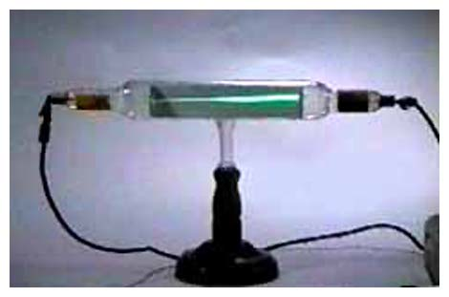
Cathode Ray Tube (CRT)- A Vacuum tube where a beam of electrons pass through and deflected by a magnetic field.
Thomson used it to discover electrons (first subatomic particle discovered)
Concluded they are negatively charged
Ernest Rutherford (1911)- Discovered the NUCLEUS
His Model of the Atom:
¨Small dense positive nucleus
¨Atom is mostly empty space

Rutherford’s Gold Foil Experiment :
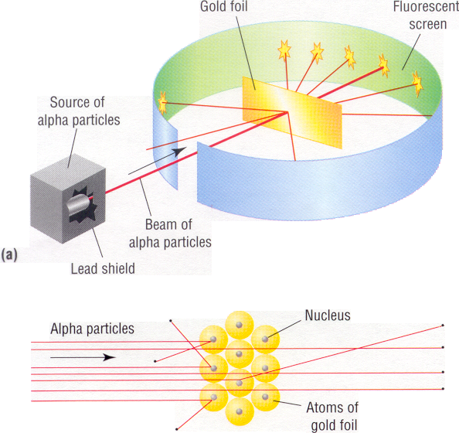
Shot beam of positive particles at gold foil:
Most went straight through
Small percent (1/8000) bounced back

Rutherford’s Conclusions:
1.) Atom is mostly empty space
2.) Small dense positive center (nucleus)

EXAMPLE:
When alpha particles are used to bombard gold foil, most of the alpha particles pass through undeflected. This result indicates that most of the volume of a gold atom consists of ____.
1. a nucleus
2. neutrons
3. protons
4. unoccupied space

MODERN THEORIES
Niels Bohr (1913)-
His Model of the Atom:
Electrons have specific amounts of ENERGY
Electrons travel around the nucleus in well-defined paths called ORBITS (like planets in a solar system)
Each distinct orbit has an associated ENERGY LEVEL

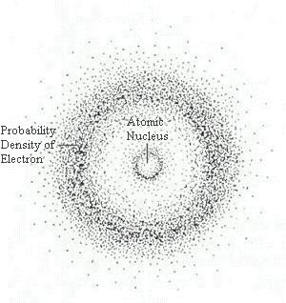
Wave Mechanical Model (current model)-
Discovery: Can only determine the probability of finding an electron
Model of the Atom: Electrons found in ORBITALS

Objective:
- Identify the subatomic particles of an atom (proton, neutron, and electron)
- Determine the number of protons, neutrons, electrons, nucleons and nuclear charge in a neutral atom

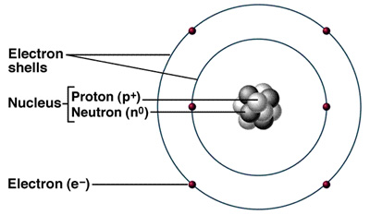
PARTS OF AN ATOM (SUBATOMIC PARTICLES):
amu = 1/12th mass of a carbon-12 atom

NUCLEONS = (PROTONS AND NEUTRONS)

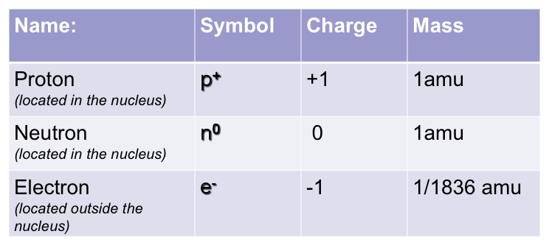

The mass of an electron is _______________
(we can “neglect” it, i.e., treat it as 0 amu)

FINDING THE NUMBER OF SUBATOMIC PARTICLES
To find the # of PROTONS:
ATOMIC NUMBER is equal to the number of protons
Every element has its own atomic number -- How periodic table is arranged
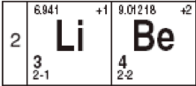
To find the # of PROTONS: Look up atomic number on periodic table.
Example: Lithium as an atomic number of _______________; Lithium has _______ protons.
Beryllium has and atomic number of ______ and ______ protons.
To find the # of ELECTRONS:
Equal to the # of protons in a neutral atom
Lithium has ___ protons, so Lithium has ____ electrons
Beryllium has ___ protons, so Beryllium has ____ electrons
MASS NUMBER: Equal to the sum of the protons and the neutrons (whole number)
Can be written as carbon-12
To find the # of NEUTRONS:
Protons + Neutrons = Mass Number
# of neutrons = mass number – number of protons
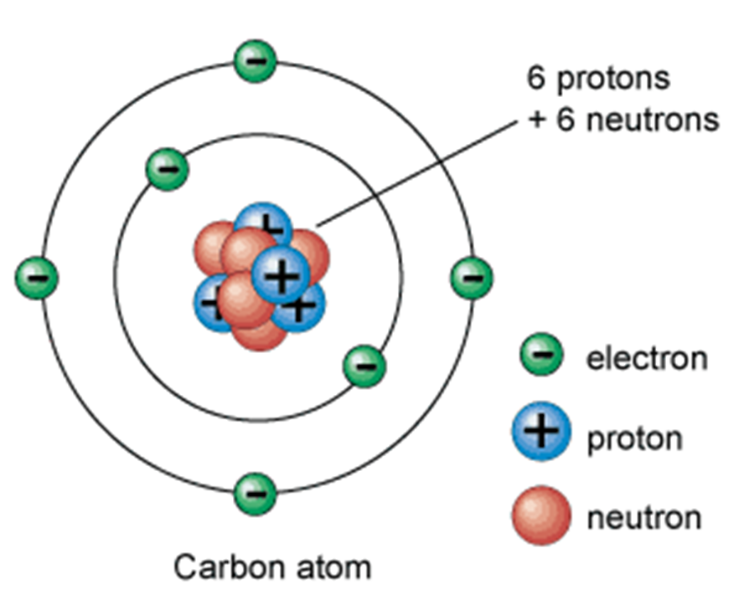
6 protons
+ 6 neutrons
12 nucleons (mass number = 12)

Ex. Lithium-7 has ____ neutrons (7 – 3) = _____
Ex. Beryllium-9 has ____ neutrons (9 – 4) = _____
To find the NUCLEAR CHARGE:
Equal to the number of protons
Ex. Lithium has a _____ nuclear charge
Ex. Beryllium has a _____ nuclear charge

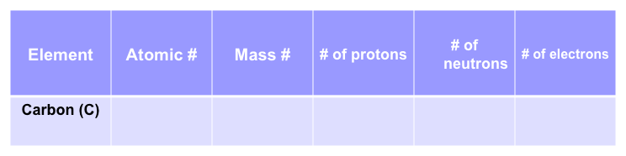
EXAMPLE: Fill in the table

(If not specified, assume mass number to be the closest whole number to the atomic mass).
Objective:
- Determine the number of protons, neutrons, and electrons in an ion

IONS:
- Charged particles
- Formed when atoms gain or lose electrons
- CHARGE = #p⁺ - #e⁻

CATION: (ca+ion)
- The atom loses e- becomes positively charged
- Ex. Na⁺

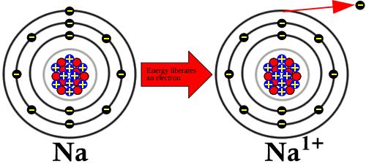
#p⁺ = _________ #p⁺ = _______
#e⁻ = _________ #e⁻ = _________
Neutral: Charged:
#p⁺ - #e⁻ = 11-11 = 0 #p⁺ - #e⁻ = 11-10 = +1

ANION: (aNion)
- The atom becomes negatively charged
- Ex. Cl⁻
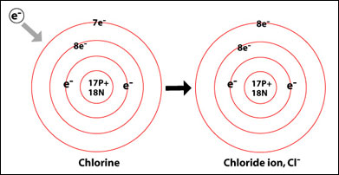
#p⁺ = _________ #p⁺ = _______
#e⁻ = _________ #e⁻ = _________
Neutral: Charged:
#p⁺ - #e⁻ = 17-17 = 0 #p⁺ - #e⁻ = 17-18 = -1

EXAMPLE:

Element | Atomic # | Mass # | p | n | e
Fe
Fe³⁺

Element | Atomic # | Mass # | p | n | e
Br
Br¹⁻

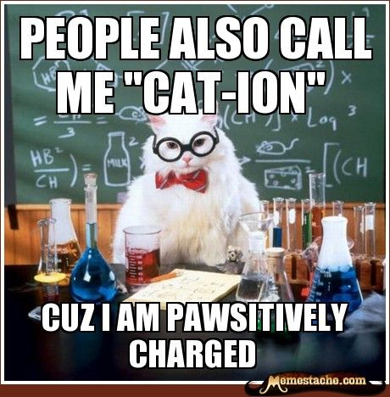

Objective:
- Differentiate between atomic number, mass number, and (average) atomic mass
- Calculate the (average) atomic mass for all isotopes of an element
- Calculate the number of neutrons in an isotope

ISOTOPES: Elements that have the same atomic number but different mass (different # of neutrons)
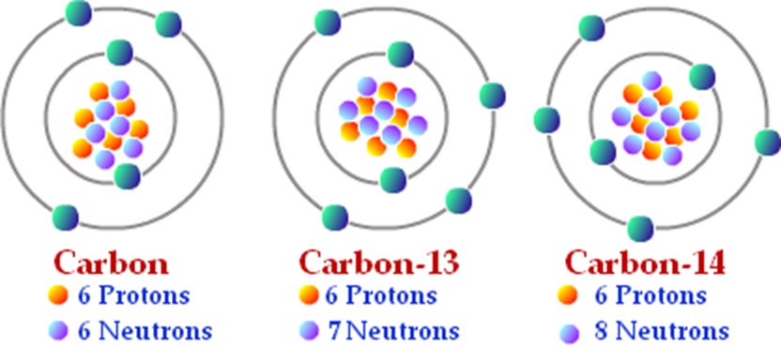

Mass# = ____ Mass# = ____ Mass# = ______
ISOTOPE = ISO (same) + TOPOS (place) – same place on periodic table (same element)
Isotope Symbols:
Show the element symbol with the mass of isotope
(Same atomic #, different mass #)
Ex. isotope symbol of element X
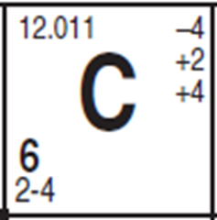
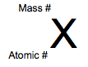
Can also be written:
X-mass#

Common Isotopes of Hydrogen:
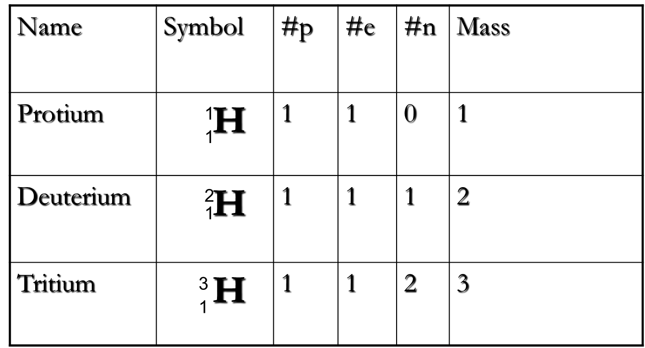

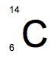
EXAMPLE: The isotope symbol for of Carbon-14
How many neutrons does it have?

EXAMPLE: Write the isotope symbol for oxygen-17.
How many neutrons does it have?

CALCULATING AVERAGE ATOMIC MASS
AVERAGE ATOMIC MASS:
The atomic mass on the periodic table is a weighted average of the naturally occurring isotopes of the elements.
The weighted atomic mass takes into account the relative abundances (amounts) of all the naturally occurring isotopes.
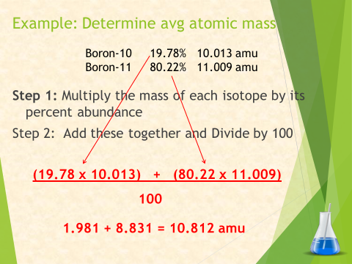

EXAMPLE: Determine weighted atomic mass
Potassium-39 93.12% 38.964 amu
Potassium-41 6.88% 40.962 amu

NOTE: You can also use the decimal value of the percent given (divide by 100 first) and then add the resulting number. For example, in the example above, 93.12% = .9312 or 93.12/100. So (.9312)(38.964) + (.0688)(40.962) is an equivalent numerical set up.

Objective:
- Construct Bohr diagrams for atoms and ions

Bohr Models
How do electrons “orbit” the nucleus? IN ENERGY LEVELS (SHELLS).
- Each principal energy level:
  - is a fixed distance from the nucleus
  - can hold a specific number of electrons
  - has a definite amount of energy

- The greater the distance from the nucleus…the greater the energy of the electrons in it.
- The ORBITS are called principal energy levels or shells.
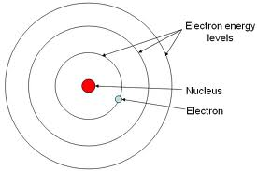
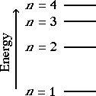

Drawing Bohr Diagrams
- Look up electron configuration on Periodic table (if it’s an ion add/subtract the e- from the outermost energy level) NOTE: The total # electrons in an atom = the atomic number
- Draw a circle for nucleus and annotate # of protons and neutrons in it.
- Draw in energy levels and notate the # of electrons in each shell
The last number, or outer shell, is the “valence” shell

EXAMPLE: Draw the Bohr diagram of Mg

EXAMPLE: Draw the Bohr diagram of Mg⁺²

EXAMPLE: Draw the Bohr diagram of Ca⁺²

IN CLASS NOTES:
Max # of Electrons in each level/shell (use electron configurations on PT):
First Shell: _____
Second Shell: ______
Third Shell: ______
Fourth Shell: _______
Objective:
- Differentiate between excited and ground state
- Explain how light is produced
- Identify substances based upon their bright line spectra

Ground State- When electrons occupy the LOWEST available ENERGY LEVELS. (configuration listed on your periodic table)
Excited State- Electrons NO LONGER occupy the lowest available energy levels (different than electron configuration on your periodic table)
Example: Possible excited state for Na
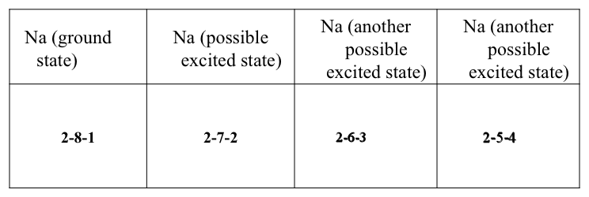

How do you tell if the configuration is ground or excited state?
- Add up total # of electrons in configuration
- Determine element (neutral atom, so #e = #p = atomic number)
- If the configuration matches the configuration on periodic table = GROUND STATE
- If it doesn’t match = EXCITED STATE

EXAMPLE: Identify the electron configuration as being ground state or excited state: 2-6-1
2 + 6 + 1 = 9, 9 is Fluorine (F)
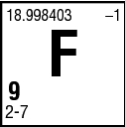

MORE EXAMPLES:
Given Shell Configuration | Add Up Electrons | Which Element | What is the Electron Configuration on the Periodic Table? | Does it Match the given configuration? | Ground or Excited?
2-8-9-2
2-7-2

*****Remember for an atom in excited state, the total # of electrons DOES NOT change

BRIGHT LINE SPECTRA
ABSORPTION:
- Electrons absorb energy as they move to higher energy levels (excited state)
- This excited state is temporary and unstable.
EMISSION:
- Electrons are negatively charged and therefore attracted to positive nucleus so eventually they fall back to ground state (lowest energy level) and release the energy they absorbed as light energy
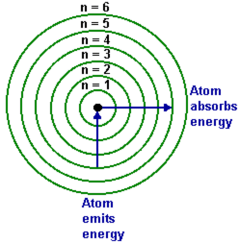

LIGHT:
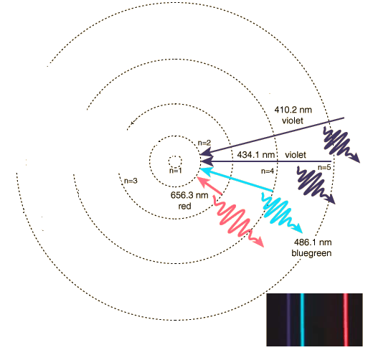
- The color of the light is determined by the amount of energy lost by the electron when it drops back to the ground state

- We can observe visible light, but IR, UV, can also be emitted).
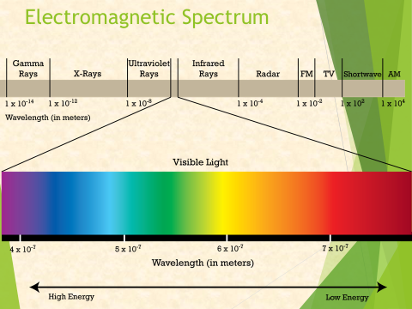

BRIGHT LINE SPECTRA:
- Each element has its own bright line spectra that is unique. (like a fingerprint)
- Can be used to identify an unknown mixture of gases.
  - EVERY LINE FROM EACH SUBSTANCES SPECTRUM WILL BE SEEN.

PRACTICE: What Gases Comprise the Unknown?
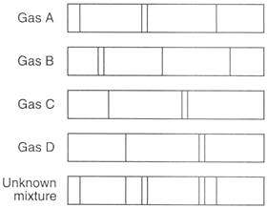

Objective:
- Construct Lewis dot diagrams for atoms and ions

Lewis Dot Diagrams (electron dot diagrams)
- Only show VALENCE ELECTRONS
- Valence shell: outer most shell of an atom that contains electrons
- Valence electrons: electrons that occupy the valence shell (last number in electron configuration)

Steps for drawing dot diagrams:
- Draw the element symbol
- Locate valence electron # (last number of electron configuration)
- Pair the first 2 electrons they deal out any remaining one at a time to other 3 sides.

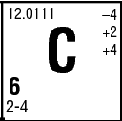
EXAMPLE: Draw dot diagram for Carbon

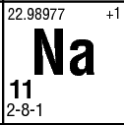
EXAMPLE: Draw the dot diagram for Na

Drawing Lewis Diagrams for IONS
- Draw brackets around the element symbol
- Write charge of ion outside bracket on top right corner of symbol
- Positive ions: no dots
- Negative ions: 8 dots (except H⁻ with only 2 electrons filling the first level).

Na Br

Atom 2-8-1 2-8-18-7
Change to Ion – 1 electron + 1 electron
Result 2-8-0 2-8-18-8

EXAMPLE: K⁺
Remove 1 electron from the valence shell of K

EXAMPLE: S⁻²
Add 2 electrons to the 6 that S normally has in its valence shell

Examples:
P and P⁻³
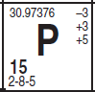

Ca and Ca⁺²
