Regents Chemistry

Notes: Unit 3 Heat

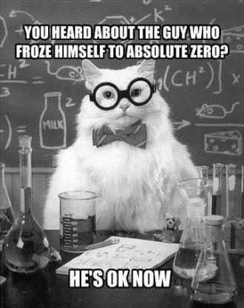

**KEY IDEAS**

* In all chemical reactions there is a conservation of mass, energy, and charge. (3.3a)
* Energy can exist in different forms, such as chemical, electrical, electromagnetic, thermal, mechanical, nuclear. (4.1a)
* Chemical and physical changes can be exothermic or endothermic. (4.1b)
* Heat is a transfer of energy (usually thermal energy) from a body of higher temperature to a body of lower temperature. Thermal energy is the energy associated with the random motion of atoms and molecules. (4.2a)
* Temperature is a measurement of the average kinetic energy of the particles in a sample of material. Temperature is not a form of energy. (4.2b)
* The concepts of potential and kinetic energy can be used to explain physical processes that include: fusion (melting), solidification (freezing), vaporization (boiling, evaporation), condensation, sublimation, and deposition. (4.2c)
* The structure and arrangement of particles and their interactions determine the physical state of a substance at a given temperature and pressure. (3.1jj)

**SKILLS**

* Describe the states of the elements at STP (3.1xviii)
* Distinguish between endothermic and exothermic reactions, using energy terms in a reaction equation or experimental data (4.1i)
* Distinguish between heat energy and temperature in terms of molecular motion and amount of matter (4.2i)
* Explain phase change in terms of the changes in energy and intermolecular distances (4.2ii)
* Qualitatively interpret heating and cooling curves in terms of changes in kinetic and potential energy, heat of vaporization, heat of fusion, and phase changes (4.2iii)
* Calculate the heat involved in a phase or temperature change for a given sample of matter (4.2iv)

|  |  |
| --- | --- |
| **Term** | **Definition** |
| Boiling | The transition of a liquid into a gas at the boiling point |
| Calorimetry | The measurement of energy change between potential and kinetic energy by measuring the temperature change induced on a measured mass of water in a calorimeter. |
| Condensing | The transition of a gas into a liquid at the boiling point. |
| Deposition | The transition of a gas into a solid. |
| Endothermic | The conversion of kinetic energy into potential energy. |
| Evaporating | The transition of the surface molecules of a liquid into a gas below the boiling point. |
| Exothermic | The conversion of potential energy into kinetic energy. |
| Freezing | The transition of a liquid into a solid at the freezing point. |
| Heat | The transfer of energy (usually thermal energy) from a body of higher temperature to a body of lower temperature. Thermal energy; the energy associated with the random motion of atoms and molecules. |
| Heat of Fusion | The energy required to melt a gram of solid at its melting point. |
| Heat of Vaporization | The energy required to boil a gram of liquid at its boiling point. |
| Kinetic energy | Energy of motion. |
| Melting | The transition of a solid into a liquid at the melting point. |
| Potential energy | Stored energy, often stored in chemical bonds. |
| Product | The substances that are formed by a chemical reaction, designated as the right side of a chemical equation. |
| Reactant | The substances that are reacted together, designated as the left side of a chemical equation |
| Specific Heat | The energy required to heat one gram of a substance by one Kelvin. |
| Sublimation | The transition of a solid into a gas. |
| Temperature | The average kinetic energy of a sample or system. |

***Objective:***

* ***Describe the different types of energy.***
* ***Define heat as a measure of kinetic or thermal energy.***
* ***Understand the difference between temperature (a measurement of the average kinetic energy of the particles in a sample of material) and heat (the total kinetic energy associated with a sample).***
* ***Determine the direction of heat flow between two objects***
* ***Describe the types of energy involved in exothermic and endothermic chemical or physical changes***

**TYPES OF ENERGY:**

**POTENTIAL ENERGY:** __________________ energy – in chemistry, associated with the chemical energy stored in chemical bonds

**KINETIC ENERGY:** Energy of _______________ – in chemistry associated with random motion of atoms and molecules

**WHAT IS HEAT?**

Heat moves

from What’s Hot

to What’s Not!

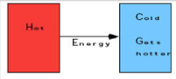Energy of random motion of atoms/molecules in a sample of matter

Heat moves from HOT objects to cold

Measured in Joules (table D)

In terms of heat flow what happens when an ice pack is placed on your skin?

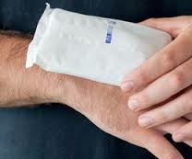

**Example:** In a laboratory, a student makes a solution by completely dissolving 80.0 grams of KNO3(s) in 100.0 grams of hot water. The resulting solution has a temperature of 60.°C. The room temperature in the laboratory is 22°C. What is the direction of heat flow?

*Answer: Heat flows from the solution (hot) to the laboratory (cold)*

**TEMPERATURE:** Measure of the _________________________________________________ of the particles in matter

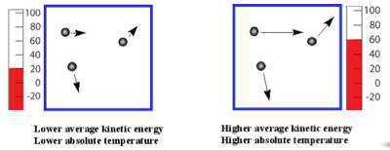

Temperature vs. Heat…

* Temperature is an ____________________________
  + *like your final grade for the quarter*
  + depends only on the motion of the particles ***(speed)***
* Heat is the ________________ energy in the system
  + *like the total number of points earned during the quarter*
  + Depends not only on the motion of the particles (temperature based on ***speed)*** but also on how many particles there are ***(mass)***

**Example:** In which sample of water do the molecules have the highest *average kinetic energy*?

a) 20. mL at 100. °C

b) 40. mL at 80. °C

c) 60. mL at 60. °C

d) 80. mL at 40. °C

**Example:** A sample of ice cools from 273K to 263K. What happens to the average kinetic energy of the molecules?

**ENERGY CHANGES DURING REACTIONS**

In chemical and physical changes, mass and energy are conserved, but… energy can be transformed

* Chemical to Thermal – Heat is released
  + EXOTHERMIC (__________…____________)
  + Ex. A + B 🡪 C + Energy
  + Energy is a *__________________*
* Thermal to Chemical – Heat is absorbed
  + ENDOTHERMIC (_______…____________)
  + Ex. A + B + energy 🡪 C
  + Energy is a *__________________*

**Examples:**

Exothermic: Combustion; acid/base reactions

Endothermic – photosynthesis, melting ice

* + Reversing a process reverses the energy conversion…
    - A + B 🡪 C + Energy
    - A + B 🡨 C + Energy

In Class Lesson:

Using Table I to determine if a change is exothermic or endothermic

“Heat of Reaction” = Energy change in a reaction

*The Sign says it all!!*

EXO OR ENDO?

Add energy as a reactant or product

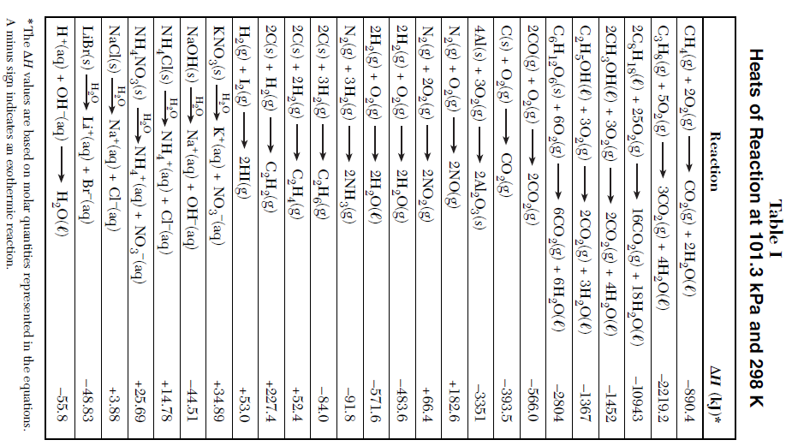

1) CH4(g) + 2O2(g) 🡪 CO2(g) + 2H2O(l)

2) N2(g) + 2O2(g) 🡪 2NO2(g)

H2O

3) KNO3(s) 🡪 K+(aq) + NO3-(aq)

***Objective:***

* ***Calculate heat, specific heat, mass, and change in temperature for a given sample of matter.***

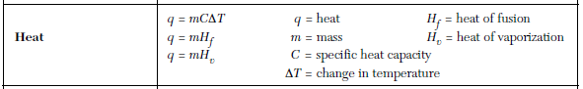**CALCULATING HEAT ASSOCIATED WITH TEMPERATURE CHANGE**

_____ is the symbol for heat

* Measured in joules or kilojoules

The heat of a temperature change is based on:

* + the ___________ of the substance *(recall heat depends on both mass and speed of particles)*
  + the ________________________________________________ it undergoes (ΔT = Tf – Ti)
  + specific heat of the substance

**SPECIFIC HEAT:** The heat needed to raise the temperature of one gram of a substance one degree Celsius. *THIS IS A PHYSICAL PROPERTY AND IS UNIQUE TO DIFFERENT SUBSTANCES!*

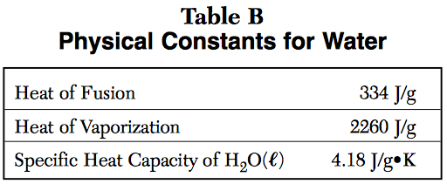

**Specific heat of water:** located on table B

**CALCULATING HEAT**

Formula on Table T:

q = mc ΔT

q = heat

m = mass

c = specific heat of substance

ΔT = final temp – initial temp

**EXAMPLE:** Solving for heat (q)

How much heat is needed to raise the temperature of 500. g of water by 15°C?

Step 1: Write the formula: q=mC ΔT

Step 2: List the variables q = ?

m = 500. g

C = 4.18 J/g°C (from Table B)

ΔT = 15°C

Step 3: Do a numerical set up (plug in the numbers):

q = (500.g)(4.18J/g°C)(15°C)

Step 4: Estimate and Calculate: q = 31350J == 31000J or 31kJ

**EXAMPLE:** Solving for specific heat (c)

The temperature of 95.4g of copper increases from 25 to 48 °C and absorbed 849J. Calculate copper’s specific heat.

Step 1: Write the formula: q=mC ΔT

Step 2: List the variables q = 849J

m = 95.4 g

C = ?

ΔT = 48-25°C = 23°

Step 3: Do a numerical set up (plug in the numbers):

849J = (95.4g)(c)(23°C)

Step 4: Estimate and Calculate: 849J = (95.4g)(c)(23°C) c =

(95.4g)(23°C) (95.4g)(23°C)

**EXAMPLE:** How many joules of heat are absorbed when 50.0g of water are heated from 30.2°C to 58.6°C?

**In Class Lesson: CALORIMETRY**

Using the Conservation of Energy together with a known standard (like water) to determine the energy change in other chemical or physical changes.

In-Class Video Notes: (https://www.youtube.com/watch?v=siIfGK4iwUw)

The amount of energy _________________ by the macadamia nut was _________________________ by the water.

The amount of energy absorbed by the water was solved using ___________________________.

q =

m=

c=

ΔT = Tf – Ti =

For best results, calorimetry should be done in a *closed system*. This means that energy is transferred between the sample and the water, but is not lost to the __________________________________.

***Objective:***

* ***Describe the structure and arrangement of particles associated with each physical state (solid, liquid, gas)***
* ***Explain phase changes in terms of the changes in potential and kinetic energy and intermolecular distance.***
* ***Identify a phase change (fusion (melting), solidification (freezing), vaporization (boiling, evaporation), condensation, sublimation, and deposition) as either endo or exothermic.***
* ***Qualitatively interpret heating and cooling curves in terms of changes in kinetic and potential energy, and phase changes.***

**REVIEW OF SOLIDS, LIQUID, GASES**

**PHASES AND STRUCTURE:**

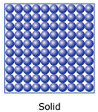**SOLIDS:**

* _________________ shape
* _________________ volume
* Constant _________________________
* Molecules are packed tightly in a geometric (crystalline) pattern

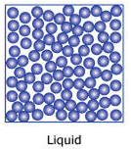**LIQUIDS:**

* _____________________ shape (take shape of container)
* ______________________ volume
* Constant ______________________________
* Loosely held together but no set arrangement
* Molecules further apart than solids but closer together than a gas

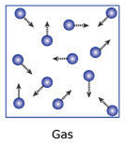

**GASES:**

* ______________________ volume (fill container)
* ______________________ shape
* Constant __________________ (most amount of movement)
* No arrangement
* Molecules are furthest apart

Solid – STRONGEST force of attraction between particles

Liquids – MODERATE force of attraction between particles

Gases – WEAKEST force of attraction between particles

**PHASE CHANGES:**

*Use the video to label the phase changes and show the direction of endo- and exothermic phase changes.*

**Solid Liquid Gas**

**Summary**

**Phase changes: ENDOthermic *Kinetic Energy converted to Potential Energy***

(s) + heat (l) ***Forces of attraction are weakened or broken.***

(l) + heat (g) ***Particles move further apart.***

(s) + heat (l)

**Phase changes: EXOthermic *Potential Energy converted to Kinetic Energy***

(l) (s) + heat ***Forces of attraction are strengthened or formed.***

(g) (l) + heat ***Particles get closer together.***

(g) (s) + heat

IN CLASS NOTES: **Phase Change Diagrams:**

**Heating Curve – starts with a solid and adds heat (energy) until the substance is a gas**

1. **Title your graph**
2. **Label your axes**
3. **Draw the line describing the relationship between temperature and heat added**
4. **Label your graph (phases and phase changes; melting and boiling point)**
5. **Use your graph: Possible questions...**

* **At what time is the sample in what state?**
* **How long was a sample in a given state?**
* **Where is greatest kinetic energy?**
* **What line segment(s) is KE constant while PE increases?**
* **How much energy to melt or vaporize your sample (assumes x-axis in Joules)**

**Cooling Curve: Describes relationship of sample temperature and phase as heat is removed.**

***Objective:***

* ***Qualitatively interpret heating and cooling curves in terms of changes in kinetic and potential energy, and phase changes.***
* ***Describe the states of the elements at STP***

**Using a Heating or Cooling Curve:**

1. **Determine if it is Heating or Cooling (heat added and temp going up or vice versa)**
2. **Label the Phases**
3. **Label the Phase Changes and MP/BP**

**_______________ Curve _________________Curve**

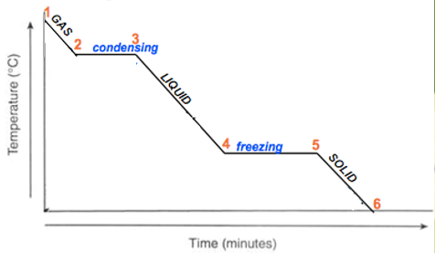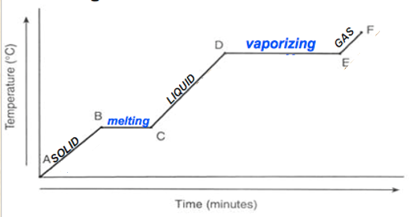

**Horizontal Parts (Plateaus):**

Temp stays the same

Kinetic energy stays the same

Potential energy changes (increases when heating, decreases when cooling)

**Vertical Parts:**

Temp changes

Kinetic energy changes (increases when heating, decreases when cooling)

Potential energy stays the same

MP

MP

BP

BP

**REMEMBER THE 4 P’s:**

* **Plateau (or “Phlat”)**
* **Phase change**
* **Physical change**
* **Potential energy change**

**Determining the Phase of a Substance Given the Temperature**

Phase depends on kinetic energy (________________________) and ___________________(forces pushing particles together)

SO…need to state conditions when doing chemistry and have defined “Standards” (Table A)

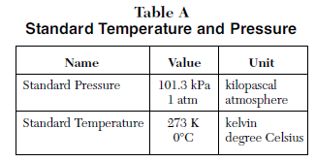

*Remember 0°C is also the freezing point of water – make a note of that on your reference table!!*

Once you have the melting point (MP) and boiling point (BP), you can use a heating or cooling curve to find the state of your substance at any given temperature.

**Example:** What is the state of H2O at 70. °C?

First, be sure to label your curve with phases and phase changes.

Then , locate 70.°C on the y-axis and look to where that intersects the heating or cooling curve to identify the state of matter at that temperature.

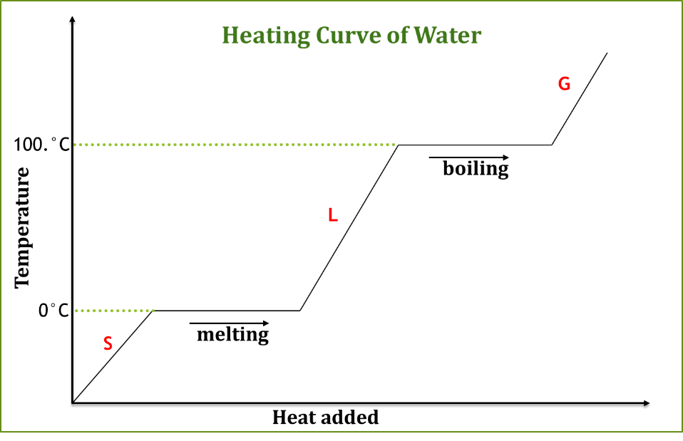

**Using Table S to find Phases of Elements (NOTE: ONLY WORKS FOR ELEMENTS)**

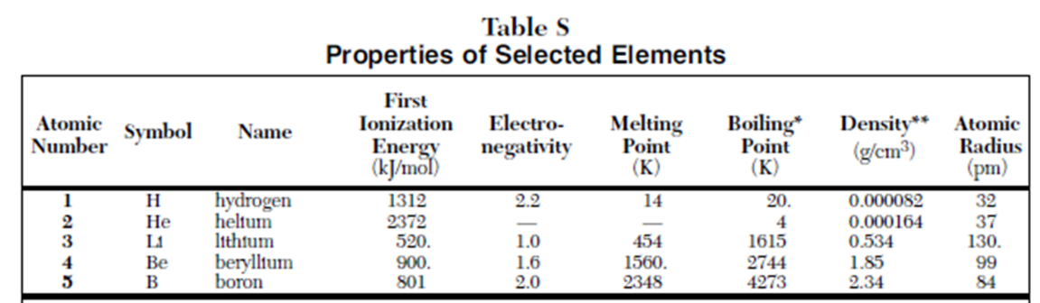

(s)< MP < (l) < BP < (g)

**If below Melting point, substance is solid.**

**Between Melting and Boiling points, substance is liquid.**

**Above Boiling point, substance is gas.**

**EXAMPLE: What phase of matter is Boron at STP?**

**From Table A, standard temperature = __________________________ (use Kelvin since Table S is in K)**

**273K < 2348K, so Boron is ________________________**

**Example: What is the phase of matter of Lithium at 500.K?**

**You can use the same logic for any substance given the melting and boiling points.**

**Example: What phase of matter is H2O @ 280 K (7°C)? *WATER IS NOT ON TABLE S!!!***

***But, we know MP = 273K, BP = 373K***

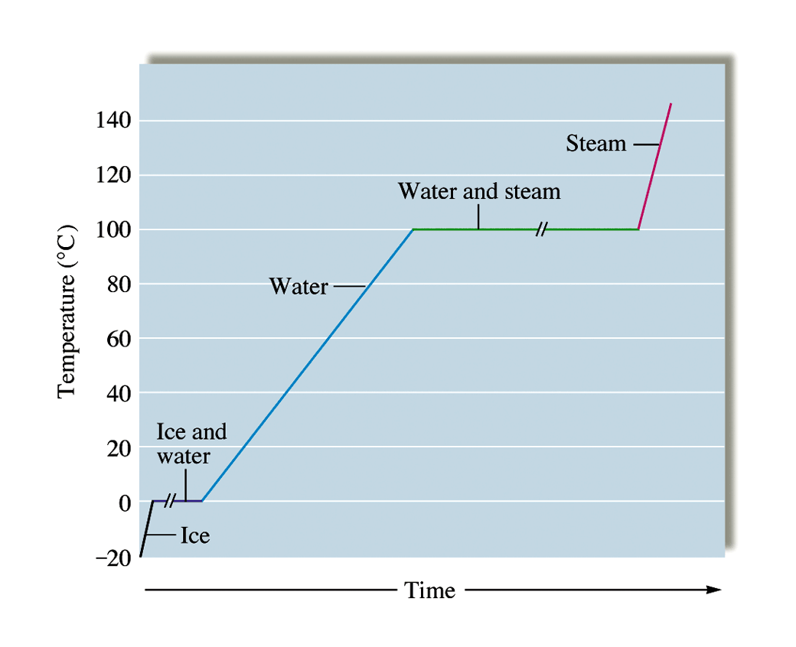

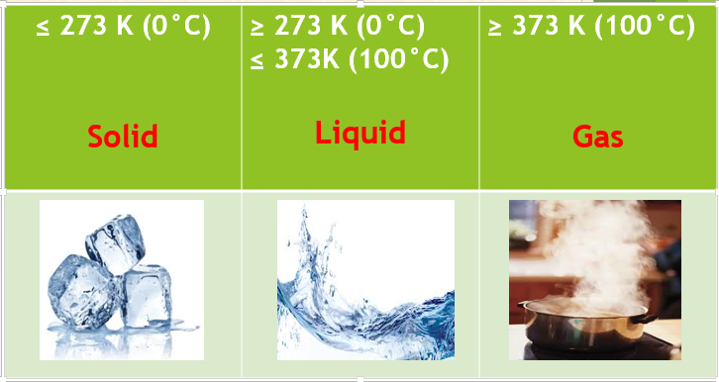

***Objective:***

* ***Calculate heat of phase changes graphically and using q=mHf and q=mHv***

There are 3 heat equations on Table T:

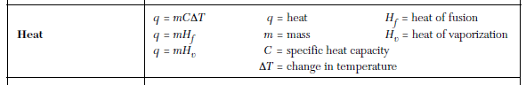

Recall that as we add heat to a sample, it either converts to kinetic energy (temperature change)or potential energy (phase change)

If the temperature changes, we can use *q = mcΔT*.

For phase changes, we will use either *q=mHf* or *q = mHv*.

**HEAT OF FUSION**

* **Fusion is another term for melting** (solid 🡪 liquid)
* It is the amount of heat (energy) needed to change one gram of a substance from solid to liquid at the melting point.
* Heat/gram = J/g

**HEAT OF *VAPOR*IZATION:**

* It is the amount of heat (energy) needed to change one gram of a substance from liquid to gas at the boiling point.
* Heat/gram = J/g

**Where on the curve determines the formula:**

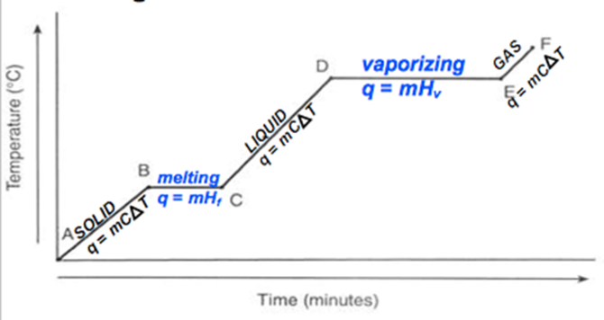

Values for Water are Located on Table B



NOTE: **The stronger the force between the particles, the greater the Hf and Hv will be – more energy needed to separate them!**

**EXAMPLE:** (Heat of fusion)

How many joules does it take to melt a 16 gram sample of water at 0°C?

q = mHf q= (16g) (334 J/g)

q = ? q = 5,344 J = 5300 J (correct precision)

m = 16g

Hf = 334 J/g (from Table B)

**EXAMPLE:** (Heat of vaporization)

How many joules does it take to boil a 250. gram sample of water at 100°C?

q = mHf q= (250. g) (2260 J/g)

q = ? q = 565,000 J or 565 kJ

m = 250.g

Hv= 2260 J/g (from Table B)

**Which formula to use?**

**Underline the key words that help you determine the formula:**

A sample of water is at 22.0ºC. A sample at 98.00ºC is added to the water and both reach a final temperature of 74.0ºC. Calculate the amount of thermal energy change for the water.

Formula:

Determine the quantity of heat released when 2.00 grams of H2O(*l*) freezes at 0ºC.

Formula:

**EXAMPLE:** How much heat is needed to melt ice at 0°C if the sample weighs 255g?

Formula: Numerical set up:

Variables: Solution:

**EXAMPLE:** Calculate the number of joules needed to vaporize 423g of H2O

Formula: Numerical set up:

Variables: Solution:

**Graphical Analysis**

A 5g sample was heated uniformly at rate of 60.J added per minute. The temperature of the sample is graphed below. How much energy was needed to melt this sample at its melting point?

Notice in problem that energy was added “per minute” so if we know how many minutes of applied heat were required…

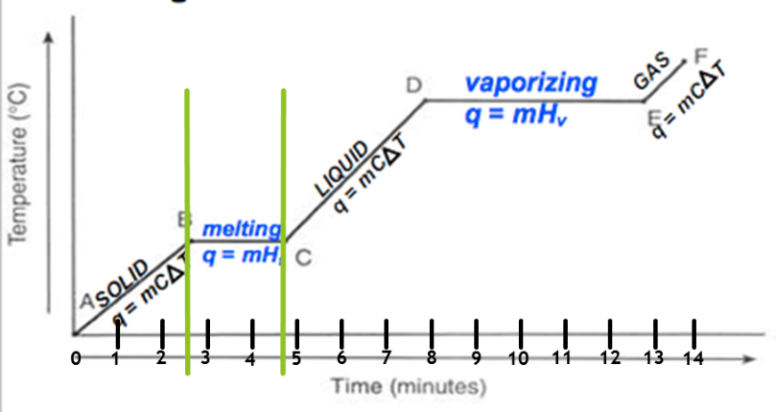

Time to melt = 2.6min to 4.8 min, or 2.2 min

At 60.J/min x 2.2 min = 130J

 **HEATING CURVE** (HEAT ADDED OVER TIME)

**Horizontal Parts (Plateaus):**

* Temp remains the same
* Avg. Kinetic energy remains the same
* Potential increases

**Vertical Parts:**

* Temp inc
* Avg. Kinetic energy inc
* Potential energy remains

the same

**COOLING CURVE** (HEAT REMOVED OVER TIME)

**Vertical Parts:**

* **Temp dec**
* **Avg. Kinetic energy dec**
* **Potential energy remains the same**

**Horizontal Parts (Plateaus):**

* **Temp remains the same**
* **Avg. Kinetic energy remains the same**
* **Potential decreases**



**REMEMBER THE 4 P’S**

* **P**lateau (“**P**hlat”)
* **P**hase change
* **P**hysical change
* **P**otential energy change

**\*\***diagonal Parts: Temperature is changing….therefore kinetic energy is changing