Name:______________________________ Date:_____________________
Lab # ___ Thickness of Aluminum Foil
Minutes: 60
Aim: Determine the thickness of a sample of aluminum foil to see whether it meets manufacturing specifications (+/- 10%).
Materials: (List all materials used). (3 pts)

Method:
1. Cut a piece of aluminum foil into a rectangle a minimum of 20cm x 30cm.
2. Measure the length and width of the foil in cm.
3. Measure the mass of the foil in g.
4. Obtain the density of aluminum from the Reference Table.
5. Calculate the volume of the foil (using data).
6. Using the formula for the volume of a rectangular prism (v=l x w x h) solve for the thickness (height) of the foil.
7. Record class data and calculate average thickness.
8. Determine the accuracy of the result (solve for percent error).

Data (in Table form): List each measurement taken and the result, to proper precision, with units. (12 pts)
Measurement: | Value (w/ units):
Length
Width
Mass
Density
Data Analysis: Use data recorded above to determine a final answer for the thickness of the sample of foil. Show all work, including formulas and numerical set ups. Box the final answer (with units). (7 pts each = 14 points)
Solve for volume:

Solve for thickness (height).

Convert answer to µm (see Table C): (5 pts)

= _____________________ µm

Class Data/Average: Record the results from each lab group below, then calculate the class average. (5 pts)

Sample | Thickness ( µm )
Group 1
Group 2
Group 3
Group 4
Group 5
Group 6
Average

Percent Error (Class Average):

For accepted value, use the manufacturer specification of 10.000 µm (8 pts)

Questions (18 pts)

1) (5 pts) In your calculations you used measurements of length, width, mass, and density. Of these, which one (or ones) was least precise? Explain why.

2) (8 pts) To increase the precision of the mass measurement, Irene suggests purchasing an electronic balance which can measure to the thousandths position. Stanley believes that all they need to do is cut a larger rectangle with a mass. Is Stanley correct? If so, how large a piece (in mass) do they need to get greater precision.

3) (3 pts) What determines if the class average for the thickness of aluminum foil is within manufacturing specifications?

4) (2 pts) Is the class average within manufacturing specifications?

Lab #3: Thickness of Aluminum Foil (To be submitted via Google Classroom)
Conclusion (35 pts)
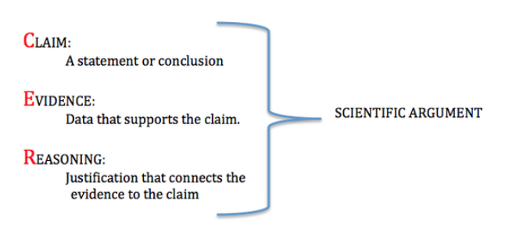

Claim: ______________________________________________________________________________
____________________________________________________________________________________

Evidence: ___________________________________________________________________________
____________________________________________________________________________________
____________________________________________________________________________________

Reasoning: ___________________________________________________________________________
_____________________________________________________________________________________
_____________________________________________________________________________________
_____________________________________________________________________________________
_____________________________________________________________________________________
_____________________________________________________________________________________
_____________________________________________________________________________________
CER Rubric
