Lab #31: Acid Base Indicators

Aim: To determine the pH of an unknown sample.

Vocabulary: (be sure to cite source) (6 POINTS):

Arrhenius Acid:

Arrhenius Base:

Indicator:

Materials (2 points):
Well Plate
Indicators (list from Table M):

Acid and Base samples
Unknown sample
pH paper

Method: Test the acid, the base and the unknown samples with the indicator given

- Place a drop of the acid in a well plate. Add a drop of indicator. Complete the data table in the lab.
- Repeat for base.
- Repeat steps 1 and 2 for each of the 7 indicators.
- Analyze results using Table M. Then test the acid and base each with pH paper and record the actual pH value.
- Test the unknown using a single indicator and record the data. Estimate the pH based on the single indicator.
- Pass your indicator data to the next lab group; receive data from the prior lab group. Do a new estimate using the two indicators.
- Continue to share data until you have completed the entire data table for the unknown. Then compare with Table M to estimate the pH (this is your experimental value).
- Finally test the unknown with pH paper and record the actual pH value.

Data & Analysis:

ACID:
Complete the data chart and then compare your results for the acid with the color guide on Table M (14 pts):
Indicator | Color in Acid | pH range (from table M)
Methyl orange
Bromthymol blue
Phenolphthalein
Red Litmus
Blue Litmus
Bromcresol green
Thymol blue

What is the pH range of your acid? (2 pts) :_________________

Test the acid with pH paper. Record actual pH: (2 pts)_________________

BASE:
Complete the data chart and then compare your results for the acid with the color guide on Table M (14 pts):
Indicator | Color in Base | pH range (from table M)
Methyl orange
Bromthymol blue
Phenolphthalein
Red Litmus
Blue Litmus
Bromcresol green
Thymol blue

What is the pH range of your base? (2 pts):_________________

Test the base with pH paper. Record actual pH: (2 pts)_________________

UNKNOWN:
Record the indicator used and color from your single indicator test. Complete the final column by comparing your color with Table M (2 pts):
Indicator | Color | pH range (from table M)

Based only on this one indicator what is the pH range of your unknown? (1 pt)____________

Trade your information with the next lab table and record both the first and second indicators along with results below (2 pts):

Indicator | Color | pH range (from table M)

Based only on these 2 indicators what is the pH range of your unknown? (1 pt)____________

Now complete the table below using data shared with all lab groups. Compare with Table M to complete the final column (5 pts):

Indicator | Color | pH range (from table M)
Methyl orange
Bromthymol blue
Phenolphthalein
Red Litmus
Blue Litmus
Bromcresol green
Thymol blue

Based on the results of all indicators what is the pH range of your unknown? (2 pts)_____________

Test the unknown with pH paper. Record actual pH: (2 pts) _________________

Is the unknown an acid or a base? (2 pts) _______________

Multiple Choice (7 points)
_______1. Three samples of the same solution are tested, each with a different indicator. All three indicators, bromthymol blue, bromcresol green and thymol blue, appear blue if the pH of the solution is
A) 4.7 B) 6.0 C) 7.8 D) 9.9
_______2.Which indicator would best distinguish between a solution with a pH of 3.5 and a solution with a pH of 5.5
A) bromthymol blue B) bromcresol green C) litmus D) thymol blue
_______3.Which indicator, when added to a solution, changes color from yellow to blue as the pH of the solution is changed from 5.5 to 8.0?
A) bromcresol green B) bromthymol blue C) litmus D) methyl orange
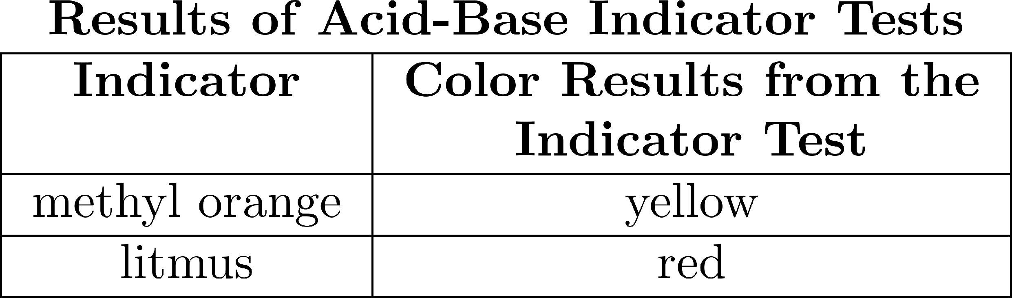
_______4. The table below shows the color of the indicators methyl orange and litmus in two samples of the same solution.

Which pH value is consistent with the indicator results?
A) 1 B) 5 C) 3 D) 10
______5. According to Reference Table M, what is the color of the indicator methyl orange in a solution that has a pH of 2?
A) blue B) yellow C) orange D) red
______6. A solution with a pH of 11 is first tested with phenolphthalein and then with litmus. What is the color of each indicator in this solution?
A) Phenolphthalein is colorless and litmus is blue. B) Phenolphthalein is colorless and litmus is red.
C) Phenolphthalein is pink and litmus is blue. D) Phenolphthalein is pink and litmus is red.
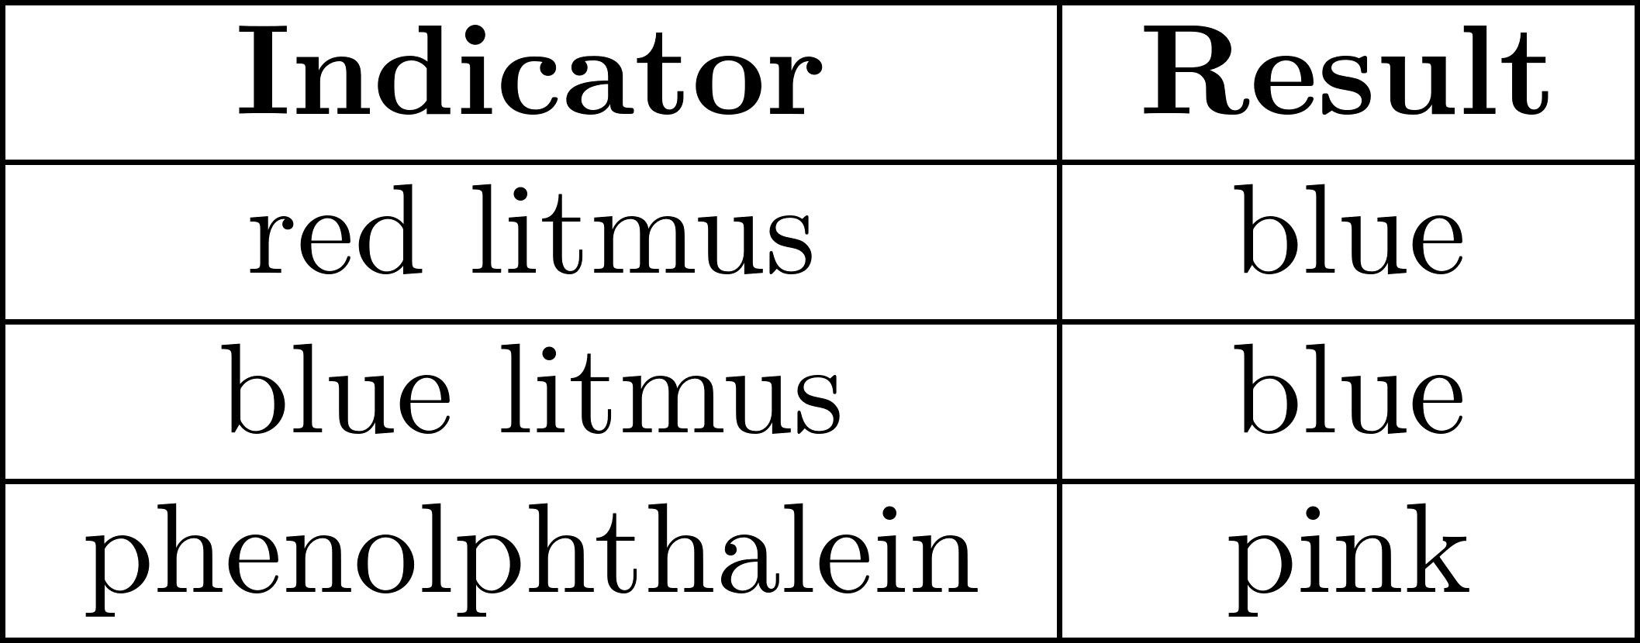
______7. The results of testing a colorless solution with three indicators are shown in the table below.

Which formula could represent the solution tested?
A) NaOH(aq) B) HCl(aq) C) C₆ H₁₂O₆ (aq) D) C₁₂H₂₂O₁₁(aq)

Name_____________________________________ Pd.________ Date_________________________

Questions (answer in full sentences). (12 POINTS)

- How did you use Table M to determine the pH of your unknown.

- Compare the accuracy of the unknown pH determined using one indicator, two indicators, and all indicators.

- What ions present in acids and bases that cause indicators to change color?

Conclusion: RERUN (20 POINTS)
Restate: aim; Explain: see question 1 Results: see analysis for unknown
Uncertainty: See question 2 New Learning: See question 3

________________________________________________________________________

________________________________________________________________________

________________________________________________________________________

________________________________________________________________________

________________________________________________________________________

________________________________________________________________________

________________________________________________________________________

________________________________________________________________________

________________________________________________________________________

________________________________________________________________________

________________________________________________________________________

________________________________________________________________________

________________________________________________________________________

________________________________________________________________________

