Safety Map of Classroom

Item # | Item | What it’s used for | How to use
1 | Fire Extinguisher
2 | Fire Blanket
3 | First Aid Kit
4 | Safety Shower
5 | Fume Hood
6 | Eye Wash
7 | Goggle Cabinet
8 | Broken Glass Disposal Box

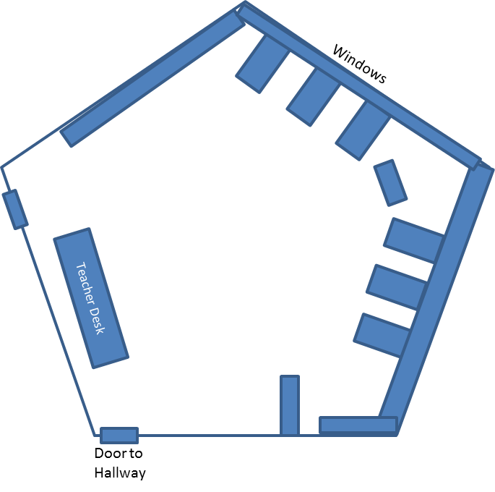
Safety Map of Classroom

Item # | Item | What it’s used for | How to use
1 | Fire Extinguisher
2 | Fire Blanket
3 | First Aid Kit
4 | Safety Shower
5 | Fume Hood
6 | Eye Wash
7 | Goggle Cabinet
8 | Broken Glass Disposal Box

